GRAMONNATI TRUST
Website Content & Strategy Blueprint
Our Story So Far | New Website Content (Page-by-Page) | Refreshed Vision & Mission | Roadmap to a World-Class Website

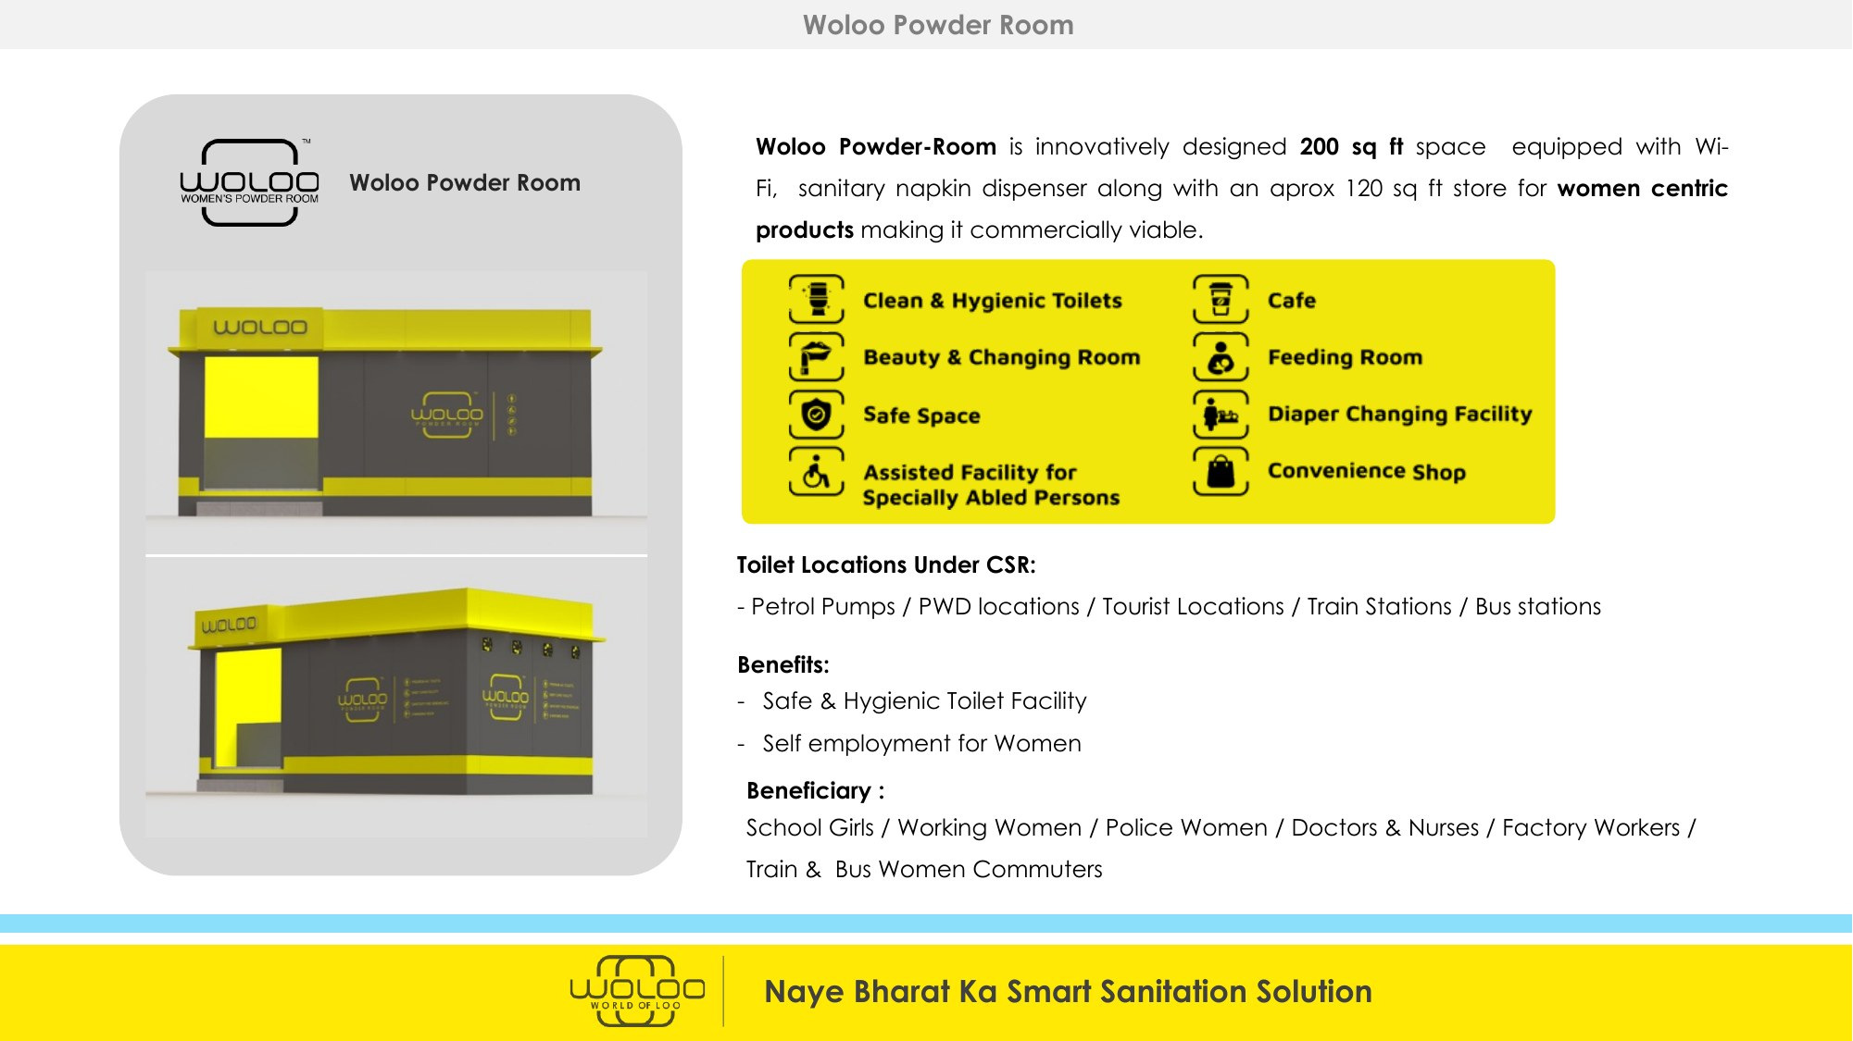

Prepared for Maj. Ved Prakash Sharma (Retd.), Founder & Chairman, Gramonnati Trust
June 2026 | www.gramonnati.org | info@gramonnati.org

PART A | Our Journey So Far
A condensed look at Gramonnati Trust's track record, partnerships and live projects — the foundation on which the new website's storytelling will be built.
1. Who We Are — At a Glance
Founded | 5th October 2017, Puducherry, as a Public Charitable Trust
Founder & Chairman | Maj. Ved Prakash Sharma (Retd.)
Registrations | 12AA · 80G (valid in perpetuity from AY 2019-20) · CSR-1 (Reg. No. CSR00017701) · PAN AACTG8992R
Operating Area | Pan-India, headquartered in Puducherry
Focus Areas | Smart sanitation infrastructure, women & veteran livelihoods, rural entrepreneurship, environment & circular economy, digital literacy

2. The Woloo Powder Room Movement
Gramonnati is the implementation partner for Woloo — India's only integrated smart-hygiene platform (Shark Tank India 2022, IIMB NSR-CEL incubation winner) — deploying ‘Powder Rooms’: 200 sq. ft solar-powered units combining clean toilets, a women's safe space, café & convenience retail, IoT hygiene monitoring, and the Loo-Locator app. Every unit is staffed by Ex-Servicewomen, War Widows and women's Self-Help Groups (SHGs).
- Proven at national scale: 46 Powder Rooms live, 1,03,909 toilet hosts onboarded across 800 cities, 1,77,204 women walk-ins in Jan '26 (10x growth since April), ₹3.5 Cr revenue FY25-26 YTD, 1 lakh+ active app users, 702 confirmed pipeline sites.
- Trusted by Indian Railways, NHAI, IOCL, BPCL, HPCL, Mumbai Metro, Adani Airports, Gujarat & Goa Tourism, and corporates including HUL, PhonePe, Nestlé, P&G and Amazon.
- Bengaluru Campaign (live, with FuelADream): a crowdfunding campaign to deploy Gramonnati's first 10 Woloo Powder Rooms across Bengaluru's BPCL/HPCL fuel stations, railway stations, and markets — ₹40 lakh per unit, 1 corporate partner = 1 unit, each serving 500+ women daily and creating 4 dignified jobs.
The Woloo Powder Room: a 200 sq. ft smart hygiene, safety and retail facility — solar-powered and women-operated.

3. Woloo Pondicherry — Our Flagship Pilot (10 Units)
Puducherry — Gramonnati's home base — is the pilot city for 10 Smart Woloo Units. Its blend of beach tourism (Beach Boulevard, White Town), spiritual tourism (Sri Aurobindo Ashram, Auroville, Manakula Vinayagar Temple), the Chennai-Pondicherry ECR corridor, and major hospitals (JIPMER, Aravind Eye Hospital) make it the ideal proof-of-concept for a replicable Tier-II/III tourism-city model.
- Goal: prove the Woloo CSR model within 6-9 months, then replicate it across Tier-II/III temple and tourism towns — Madurai, Tirupati, Trichy, Rameswaram, Thanjavur, Kanyakumari and beyond.
- Operating model: women-led, military-style discipline — City Leader (retired woman officer), Cluster/SHG Heads (war widows), and Retail & Cleaning Staff (war widow families and local SHGs).
- Sponsorship tiers structured for CSR & philanthropic donors: Title Partner (₹2-5 Cr, naming rights across all 10 units) down to Women Dignity Partner (₹10-25 lakh, CSR recognition panels).
4. Clean & Divine India — The Guilt-Free Travel Initiative
Our flagship national programme pairs two infrastructure units at India's highest-footfall destinations: Woloo Women's Powder Rooms (dignity & hygiene) and New Age Dry Waste-to-Pellet Plants (10 TPD, converting tourist waste into RDF pellets sold to industry). Both are operated entirely by War Widows and Ex-Servicemen.
- The mechanism: a voluntary ₹10 ‘Guilt-Free Travel’ contribution embedded at checkout on OTAs (MakeMyTrip, GoIbibo and global platforms), tagged to a specific destination, with a live QR-code impact dashboard.
- At moderate uptake (20% opt-in on ~50M annual MMT transactions) this unlocks a ₹10 crore/year Clean Destination Fund — enough for 6 Pellet Plants + 33 Powder Rooms, creating 120+ Ex-Servicemen jobs and ~100 War Widow livelihoods.
- Fully aligned with Swachh Bharat Mission, the PRASHAD pilgrimage scheme, EPR plastic-waste rules, National Tourism Policy 2022, and UN SDGs 6, 11 and 12.
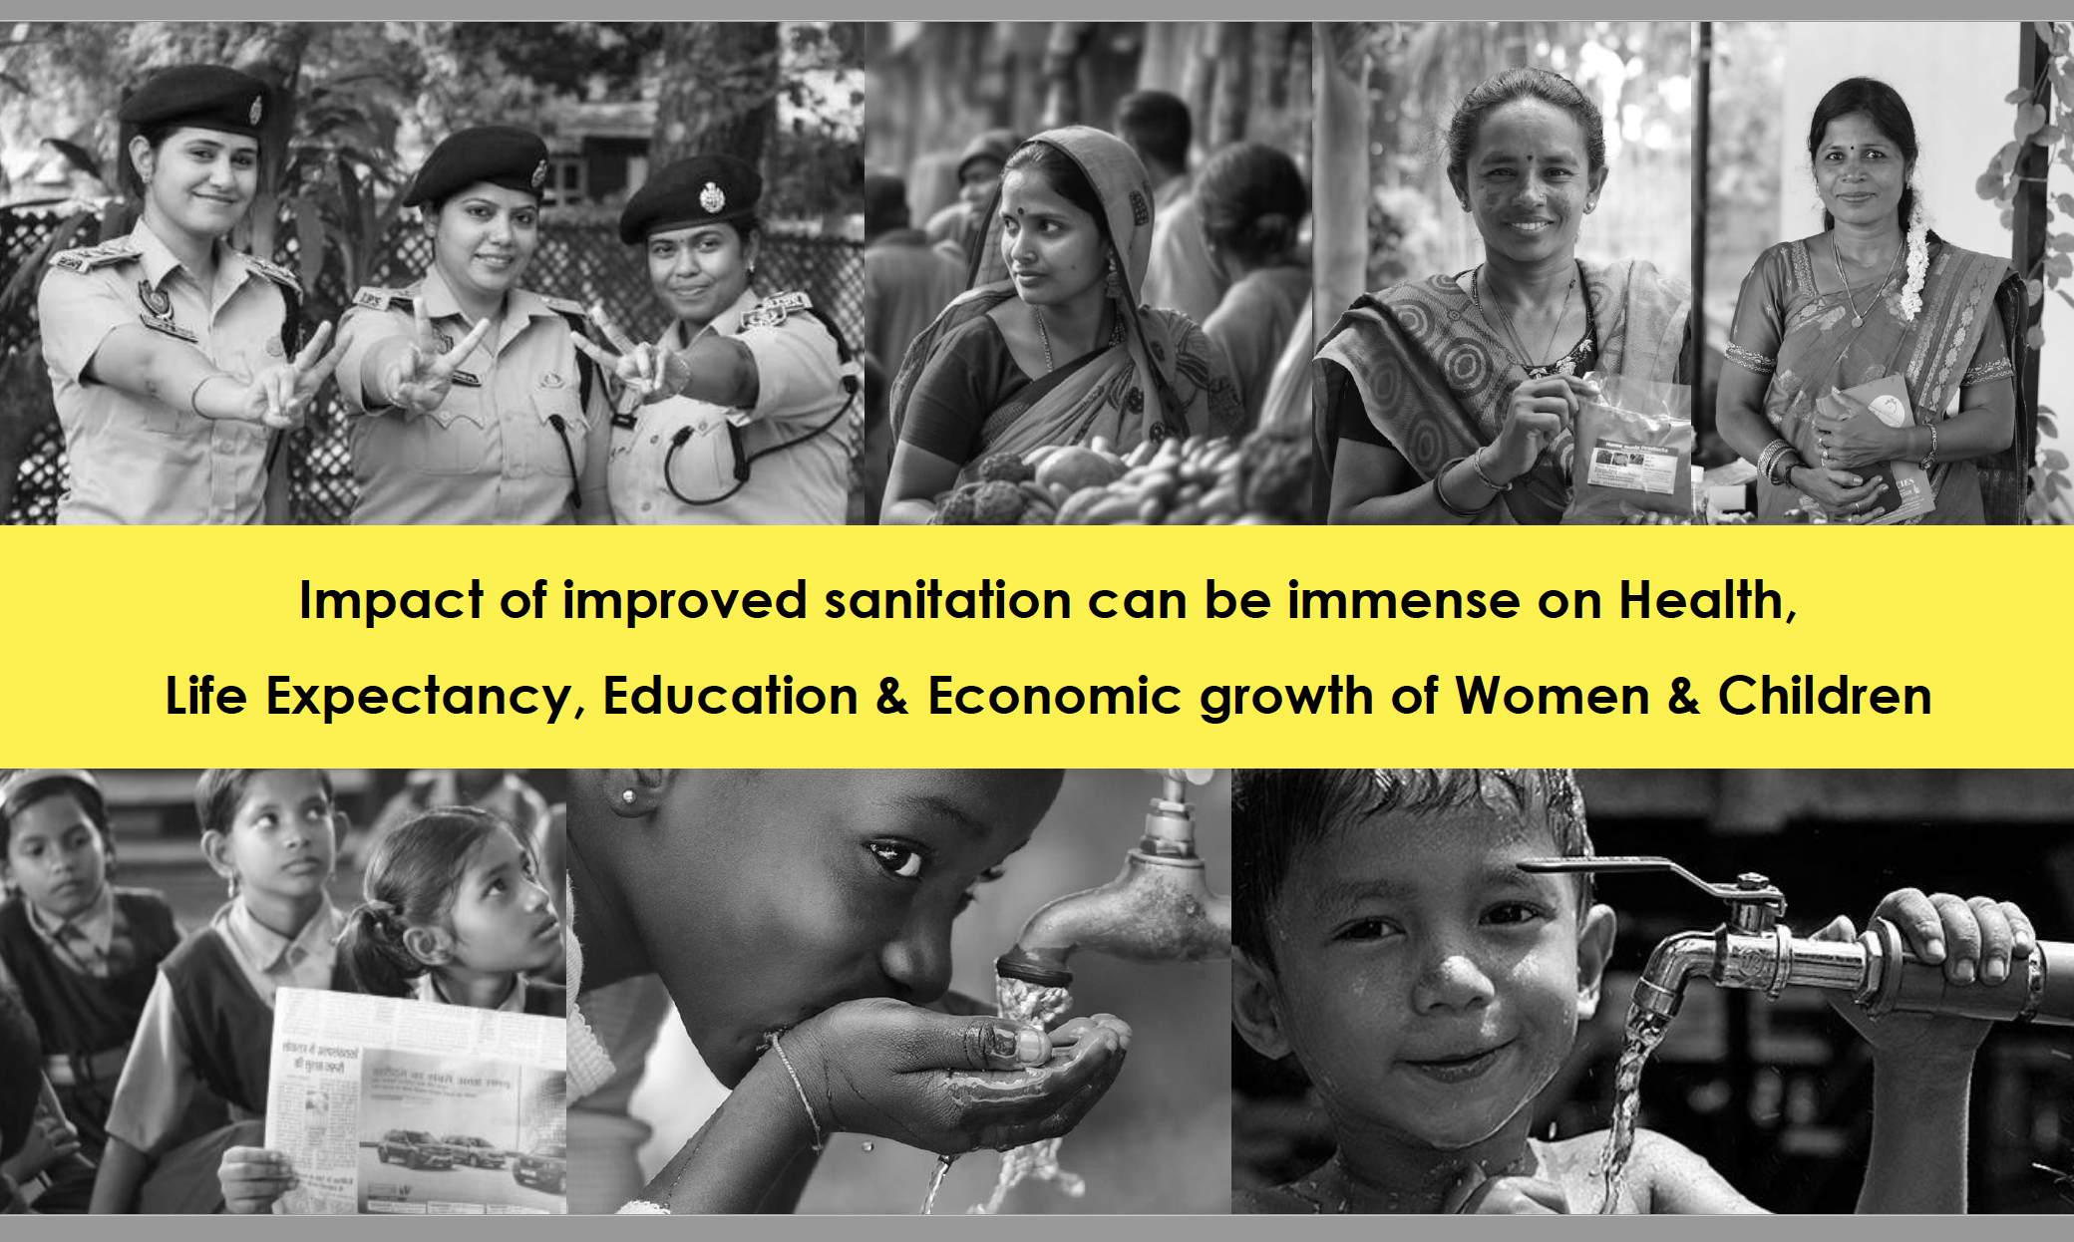
The case for clean, dignified sanitation: improved hygiene transforms health, education and economic outcomes for women and children.

5. The National Vision — 1,00,000 Woloo Powder Rooms, Pan-India
Beyond individual projects, Gramonnati's CSR Partnership proposal frames a 10-year national infrastructure vision: 1,00,000 Woloo Powder Rooms deployed across religious pilgrimages, petrol stations, railway & bus stations, national highways, urban markets and institutions — creating 4 lakh dignified jobs and 1 lakh women-led micro-enterprises for Ex-Servicewomen, War Widows and SHG women.
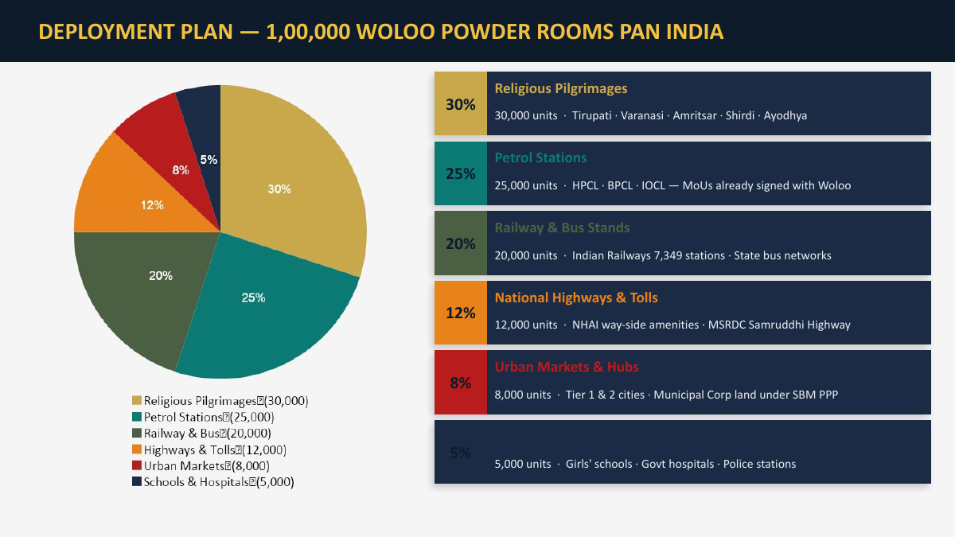
Proposed national deployment plan for 1,00,000 Woloo Powder Rooms across six high-footfall categories.
- Partnership tiers range from Community Partner (₹50L-2Cr, 25-100 rooms) to Mission Partner (₹25Cr+, 1,250+ rooms, naming rights and a board observer seat).
- Every partner receives 80G tax certificates, CSR-1 documentation, BRSR-ready ESG data, IRIS+-aligned impact reporting, India CCTS carbon-credit certification, and live unit-level dashboards.

PART B | Vision & Mission — Refreshed for Deep Impact
Gramonnati's current vision and mission (below) were written when the Trust's focus was primarily rural upliftment through entrepreneurship and technology. Since then, the Trust has built a second, equally powerful identity: India's leading deployer of dignity-led sanitation infrastructure, staffed by women and veterans. The suggestions below retain the founding spirit while making room for this — and for the scale Gramonnati is now pursuing.
Current Vision & Mission (for reference)
Vision
“To create self-reliant, prosperous and sustainable villages where every citizen has equal opportunity, dignity, and access to knowledge and modern systems.”
Mission
- Enable rural communities with knowledge, leadership, and execution capabilities for holistic village transformation
- Break the cycle of poverty by creating new entrepreneurial opportunities and possibilities
- Promote environmental stewardship, organic farming, and sustainable resource management
- Develop and deploy integrated technological solutions suited to the needs of rural India
- Collaborate with government, NGOs, research institutions, and corporates for maximum impact
Suggested Refreshed Vision — Three Options
Option 1 — “Dignity at Scale” (Recommended)
“An India where every village is self-reliant, every woman and veteran has dignified work, and every public space — from a village well to a pilgrimage town — reflects the cleanliness, safety and dignity all Indians deserve.”
Why this works: it widens the original village-centred vision to explicitly cover the Woloo / sanitation / tourism work, while keeping rural upliftment, women and dignity at the centre — themes that resonate strongly with both CSR and crowdfunding audiences.
Option 2 — “From Service to Stewardship”
“To build a Naya Bharat where ex-servicemen, war widows and rural women lead the next wave of nation-building — through enterprises that clean our cities, heal our villages, and restore dignity to everyday life.”
Why this works: foregrounds the veteran/war-widow narrative that is proving highly compelling to CSR partners (FuelADream deck, MakeMyTrip proposal) and gives the brand a strong emotional anchor (‘Jai Hind’ ethos).
Option 3 — “Circular, Self-Reliant Communities”
“Self-reliant villages and clean, dignified public spaces — built and run by the women and veterans who serve them — powered by technology, enterprise and environmental stewardship.”
Why this works: emphasises the circular-economy and self-sustaining-enterprise angle (waste-to-pellet, revenue-generating Powder Rooms) that differentiates Gramonnati from donation-dependent charities.
Suggested Refreshed Mission — Five Pillars
A single mission statement, expressed as five pillars, gives the website (and CSR decks) a consistent framework that every project — current or future — can be mapped to:
- Dignified Livelihoods for Those Who Served — Create stable, respected employment for Ex-Servicemen, Ex-Servicewomen, War Widows and rural women through enterprise-based community infrastructure.
- Smart Sanitation & Hygiene Infrastructure — Deploy and operate technology-enabled Woloo Powder Rooms and public hygiene facilities at the places India needs them most: pilgrimage towns, highways, railway stations, urban markets and villages.
- Circular Economy & Environmental Stewardship — Convert waste into value (Waste-to-Pellet RDF units), promote organic farming, water conservation and afforestation, and pursue carbon-credit revenue that funds further impact.
- Rural & Women's Entrepreneurship — Train, finance and mentor rural women and youth into self-employment and SHG-led micro-enterprises, breaking the cycle of poverty at the household level.
- Technology, Transparency & Partnerships — Use IoT, apps and live dashboards to make every rupee and every outcome auditable, and build long-term partnerships with government, corporates, OTAs and global platforms.
On “Deep Impact Over the Coming Years”
The documents reviewed show Gramonnati moving from a single-trust, single-state organisation to the execution backbone of a national (and potentially global-travel-linked) infrastructure movement — 1,00,000 Woloo units, a national Clean Destination Fund, and a replicable Tier-II/III city model starting in Pondicherry and Bengaluru. The website should be built to carry this story credibly: each project page should read as a chapter of one larger movement, not a standalone appeal. Suggested framing line for the homepage and About page:
“We started with one village. Today, we're building the infrastructure of dignity for a billion Indians — one Powder Room, one pellet plant, one self-reliant community at a time.”

PART C | New Website Content — Page by Page
The content below is written ready-to-use: paste each section into its page on the new site. Headings shown as ALL-CAPS / Title Case indicate on-page headings; bracketed notes [in italics] are instructions for the web developer, not copy.
Recommended Sitemap
- Home
- About Us (Our Story · Vision & Mission · Governance · Credentials)
- Our Projects (overview) →
- Woloo Pondicherry
- Woloo Bengaluru
- Clean & Divine India
- Travel Partnerships (Guilt-Free Travel / MakeMyTrip)
- Impact & Transparency (live numbers, SDGs, audits, downloads)
- Partner With Us (CSR Partners · Crowdfunding & Donations · Volunteer)
- Stories & Media (news, press, blog, photo/video gallery)
- Contact Us

Page 1 — HOME
[Goal: a CSR head or crowdfunding visitor should, within 10 seconds, understand WHO we are, WHAT we build, WHY it matters, and HOW to act. Every section below should lead the eye toward a CTA.]
Hero Section
Headline:
“Building India's Infrastructure of Dignity — One Powder Room, One Community at a Time.”
Sub-headline:
Gramonnati Trust designs, builds and operates smart sanitation, livelihood and rural-enterprise infrastructure across India — run by the women and veterans who serve our nation. 80G & 12A certified. CSR-1 registered (CSR00017701).
Primary CTAs:
- [Button] Partner With Us (CSR) → Partner With Us page
- [Button] Fund a Powder Room (Crowdfunding) → FuelADream campaign / Partner With Us page
- [Button] See Our Impact → Impact & Transparency page
[Visual: rotating hero image/video — Woloo Powder Room exteriors, women SHG staff, ex-servicewomen in uniform, Pondicherry beach road. Use image4.jpg as primary hero.]
Impact Strip (animated counters)
Metric | Current | Headline for site
Powder Rooms live | 46 | 46 Smart Hygiene Units Operating Today
Women served / month | 1,77,000+ | 1.77 Lakh Women Served Every Month
App users | 1,00,000+ | 1 Lakh+ Citizens Use Our Loo-Locator App
Jobs created (current) | 180+ | 180+ Dignified Jobs for Veterans & Women
Revenue generated FY25-26 | ₹3.5 Cr | ₹3.5 Cr in Self-Sustaining Revenue
10-Year Vision | 1,00,000 units / 4,00,000 jobs | Scaling to 1,00,000 Units & 4 Lakh Jobs Nationally

“What We Do” — Four Pillars (icon cards)
- Smart Sanitation Infrastructure — Woloo Powder Rooms: clean toilets, women's safe spaces, cafés and IoT hygiene monitoring at India's highest-need locations.
- Dignified Livelihoods — Ex-servicewomen as Zone Commanders, War Widows as Cluster Operators, SHG women as retail & hygiene staff: every unit is a livelihood engine.
- Circular Economy & Environment — Waste-to-Pellet plants turn tourist and urban waste into industrial fuel; water bodies, afforestation and organic farming restore village ecosystems.
- Rural Enterprise & Technology — Training, mentoring and digital tools that turn rural women and youth into entrepreneurs and job-creators.
Featured Projects (4 cards, each links to its own page)
Card 1 — Woloo Pondicherry: India's First Smart Hygiene City Pilot
10 smart Woloo units across Puducherry's beaches, heritage town and ECR corridor — proving a replicable model for India's temple and tourism towns. [Learn More →]
Card 2 — Be Bengaluru's First: Fund a Woloo Powder Room
A live crowdfunding campaign with FuelADream — ₹40 lakh funds one complete Powder Room, serving 500+ women daily and creating 4 jobs. [Learn More →]
Card 3 — Clean & Divine India: Guilt-Free Travel
₹10 at checkout. A cleaner destination. A war widow's livelihood. See how a micro-contribution becomes a movement. [Learn More →]
Card 4 — Travel Industry Partnerships
How OTAs, airlines and travel brands can embed Guilt-Free Travel into their booking journeys — and turn every trip into nation-building. [Learn More →]
Why Partner With Gramonnati
- Fully compliant: 12AA, 80G (perpetual, AY 2019-20 onward), CSR-1 (CSR00017701), PAN AACTG8992R — every donation is tax-deductible and CSR-eligible under Schedule VII.
- Proven delivery partner: implementation arm for Woloo (Shark Tank India 2022) — 46 units live, ₹3.5 Cr revenue, IoT-verified impact data.
- Radical transparency: live unit-level dashboards, annual CA-audited reports, IRIS+-aligned KPIs and BRSR-ready ESG data packs for every partner.
- A story worth telling: every rupee funds a war widow's job, a clean toilet, or a cleaner pilgrimage town — content-ready for your CSR/ESG report.
Recognition & Network
[Logo strip] Woloo · FuelADream · Indian Railways · NHAI · IOCL · BPCL · HPCL · Mumbai Metro · Gujarat Tourism · Goa Tourism · HUL · PhonePe · Nestlé · P&G · Amazon — plus: “As seen on Shark Tank India 2022” and “IIMB NSR-CEL Incubation Winner”.
Final CTA Banner
“Your contribution doesn't just fund infrastructure — it funds dignity for those who gave everything for India.”
[Button] Become a CSR Partner | [Button] Donate via FuelADream | [Button] Download our Trust Profile (80G/12A/CSR-1)

Page 2 — ABOUT US
Our Story
Gramonnati — meaning ‘village upliftment’ — was founded on 5th October 2017 in Puducherry by Maj. Ved Prakash Sharma (Retd.), Shri Shyamasundar Kaluve and Shri Suresh Narayan Subbarao, with a simple conviction: rural India does not need charity, it needs capability. What began as a mission to equip villages with knowledge, leadership and entrepreneurial tools has grown into a pan-India movement — one that today designs and operates smart sanitation infrastructure, creates dignified livelihoods for war widows and ex-servicemen, and is building a circular economy around waste and tourism.
From a single Trust headquartered in Puducherry, Gramonnati is now the execution partner of choice for one of India's most recognised hygiene-tech platforms (Woloo, Shark Tank India 2022), a crowdfunding partner (FuelADream), and the architect of a national proposal to deploy 1,00,000 smart hygiene units across the country.
Vision
“An India where every village is self-reliant, every woman and veteran has dignified work, and every public space — from a village well to a pilgrimage town — reflects the cleanliness, safety and dignity all Indians deserve.”
[See Part B of this document for two alternative vision statements to choose from.]
Mission
- Dignified Livelihoods for Those Who Served — stable, respected employment for Ex-Servicemen, Ex-Servicewomen, War Widows and rural women.
- Smart Sanitation & Hygiene Infrastructure — technology-enabled Woloo Powder Rooms wherever India needs them most.
- Circular Economy & Environmental Stewardship — waste-to-value, water conservation, afforestation, organic farming.
- Rural & Women's Entrepreneurship — training, financing and mentoring rural women and youth into self-employment.
- Technology, Transparency & Partnerships — IoT dashboards, audited reporting, and partnerships with government, corporates and global platforms.
Governance & Credentials
Founded | 5th October 2017, Puducherry
Registered Office | 10, L'Avenir III, No. 108, Papammal Koil Street, Kuruchikuppam, Puducherry – 605 012
PAN | AACTG8992R
12AA Registration | AACTG8992R/05/18-19/T-0831 (w.e.f. 05.10.2017)
80G Certification | URNo. AACTG8992R/05/18-19/T-0831/80G — valid in perpetuity from AY 2019-20
CSR Registration | CSR00017701 (Ministry of Corporate Affairs, Govt. of India)
Area of Operation | Pan-India, primary focus on Puducherry & rural South India
Audit | Annual audit by Chartered Accountant; financial year 1 April – 31 March

Leadership
- Maj. Ved Prakash Sharma (Retd.) — Founder & Chairman
- Shri Shyamasundar Kaluve — Founder Trustee
- Shri Suresh Narayan Subbarao — Founder Trustee
- Smt. Ayushi Sharma & Shri Atul Krishan Sharma — Trustees
The Trust is irrevocable, operates without profit motive, and applies its income solely to its charitable objects — no benefit accrues to any trustee or member.
Why Partner With Gramonnati
- Proven track record with government & tax-exempt status; eligible vehicle for corporate CSR under the Companies Act.
- Deep grassroots presence in Puducherry and rural South India, with national-scale infrastructure partnerships.
- Transparent governance, annual audits, and full compliance (80G, 12AA, CSR-1, IRIS+, BRSR-ready).
- Experienced founding team combining military, corporate and social-sector expertise.
- Aligned with national priorities: Swachh Bharat 2.0, women's empowerment, veterans' welfare, rural employment, environment.

Page 3 — OUR PROJECTS (Overview)
Headline:
“One Mission. Four Frontlines.”
Intro copy:
Every Gramonnati project shares one DNA: infrastructure that serves a real public need, built and run by women and veterans, measured transparently, and designed to become self-sustaining. Explore our current frontlines below.
[4 cards, same as Homepage Featured Projects — link each to its dedicated page below.]
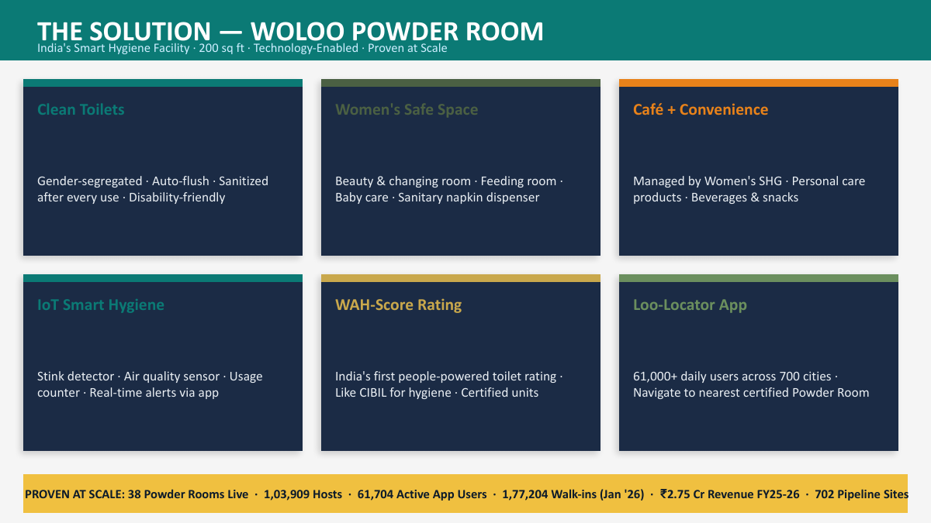
The Woloo Powder Room model — the common building block across all four projects.

Page 3.I — PROJECT: WOLOO PONDICHERRY
Hero
Headline:
“India's First Smart Hygiene City — Starting at Home, in Puducherry.”
Sub-headline:
10 Smart Woloo Powder Rooms across Puducherry's beaches, heritage town, ECR highway and healthcare hubs — a pilot designed to become the template for every temple and tourism town in India.
[CTA] Sponsor a Unit | [CTA] Download the Pondicherry Project Note
Why Pondicherry
Puducherry is Gramonnati's home — giving the project deep local knowledge, strong networks, and fast coordination with a compact, supportive Union Territory administration. Despite its small size, Puducherry draws very high tourist footfall year-round across Beach Boulevard, White Town and the ECR corridor, and is a globally recognised spiritual destination (Sri Aurobindo Ashram, Auroville, Manakula Vinayagar Temple) — drawing large numbers of women travellers and senior citizens who need clean, safe sanitation. Add the Chennai–Puducherry ECR's heavy highway traffic and major hospitals (JIPMER, Aravind Eye Hospital, Government General Hospital), and Puducherry becomes the perfect proving ground for a visible, sustainable, nationally replicable model.
Our Objectives
- Establish 10 smart Woloo Powder Rooms across Puducherry to close the gap in women's sanitation in a high-tourism city.
- Prove the efficacy of the Woloo CSR-based model within 6-9 months.
- Develop a replicable Tier-II/III city model for similar tourism and religious-tourism cities.
- Employ ex-servicewomen, war widows and SHG women — creating women-led micro-enterprises.
Where the Units Will Be
- Priority sites: Beach Boulevard / White Town heritage zone, Auroville wellness corridor.
- Other Puducherry sites across the city's key tourist and civic zones.
- Chennai–Puducherry ECR corridor (100 km stretch), including Mahabalipuram.
The Woloo Wellness Retail Model — Beach Boulevard Unit
Our flagship unit is designed as a premium ‘Smart Hygiene + Wellness Retail’ destination — combining pay-and-use sanitation with café operations, wellness retail, advertising and tourism convenience services, leveraging beach tourism, White Town heritage tourism, the Auroville wellness ecosystem, ECR traveller movement, and women's safety demand. It operates simultaneously as: a premium sanitation facility, a women's safety infrastructure point, a wellness café & retail outlet, a tourism convenience centre, and a CSR/ESG branding destination.
Who Runs It — A Women-Led, Veteran-Anchored Model
Role | Preferred Profile
City Leader (1) | Retired Woman Officer — Army / Navy / Air Force
Cluster / SHG Heads (2, each manages 5 units) | War widows / family members of ex-servicemen with leadership experience
Retail & Café Staff (20-24) | War widows / daughters / spouses of ex-servicemen
Cleaning Staff (20-24) | Women SHGs and economically vulnerable local women
Maintenance Technician (1) | Local technical resource (plumbing/electrical)
Accounts & Admin Support (1) | Administrative staff with accounting knowledge

Partner With This Project — Sponsorship Tiers
Sponsorship Level | Contribution | What You Get
Title Partner | ₹2-5 Cr | Naming rights across all 10 units
Zone Sponsor | ₹50L-1 Cr | Branding on 1-2 landmark units
Unit Sponsor | ₹50L | Full branding on one Woloo unit
Smart Hygiene Partner | ₹25L+ | Digital screens + app branding
Women Dignity Partner | ₹10-25L | CSR recognition panels

Every unit can generate 1-2 lakh physical impressions/month, with QR-based engagement, ESG/BRSR-ready reporting, and direct alignment with Smart City and Swachh Bharat branding.
The Long-Term Opportunity
The Pondicherry pilot is designed to become the template for Tier-II/III temple and tourist towns across India — Madurai, Tirupati, Trichy, Rameswaram, Thanjavur, Chidambaram, Kanyakumari, and beyond.

Page 3.II — PROJECT: WOLOO BENGALURU
Hero
Headline:
“One Powder Room. 500 Women Served. Every Day.”
Sub-headline:
10 Smart Woloo Powder Rooms across Bengaluru's fuel stations, transit hubs, religious sites and markets — built on a model already proven across 46 units, 1,77,204 footfalls and ₹3.5 Cr revenue.
[CTA] Fund a Unit on FuelADream | [CTA] Become a Corporate Funder
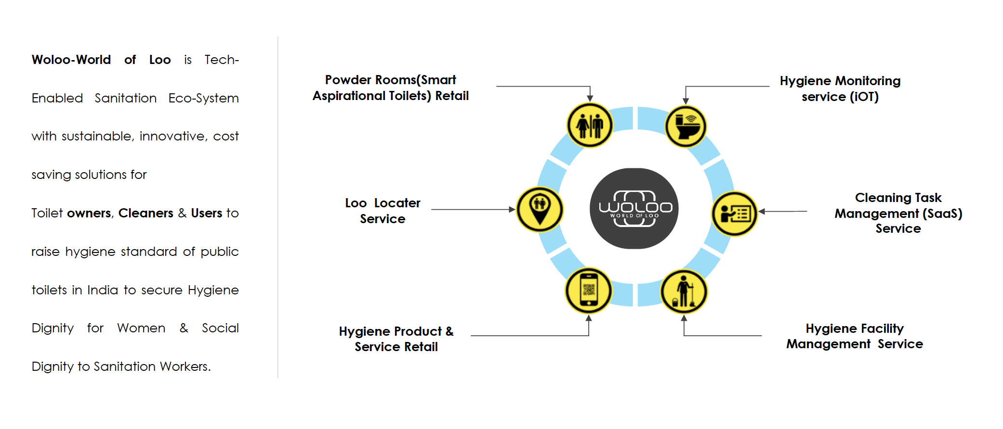
The Woloo Ecosystem — TASQ-Master, Loo-Locater App, and the Smart Powder Room working together.
Why Bengaluru, Why Now
Bengaluru's working women, gig-economy riders, bus and metro commuters, and daily market-goers all face the same gap: nowhere clean, safe, or dignified to go. Woloo closes that gap with 10 new units strategically placed at:
- Fuel retail outlets (BPCL / HPCL forecourts)
- Railway stations and bus terminals (BMTC/KSRTC)
- Religious and pilgrimage sites
- Urban wholesale and retail markets
The Proven Model — Numbers That Speak
Metric | Achieved So Far
Units operational | 46
Total walk-ins served | 1,77,204
Revenue generated | ₹3.5 Cr
Hosts (women operators) trained | 1,03,909
Pipeline units in development | 702
App users (Loo-Locater) | 1,00,000+

What ₹40 Lakh Builds
Component | Investment
Construction & smart infrastructure (per unit) | ₹25,00,000
12-month operations & staffing (per unit) | ₹15,00,000
Total per unit | ₹40,00,000
Campaign target (10 units) | ₹4,00,00,000

Recognition — The Gratitude Wall
Tier | Contribution | Recognition
Corporate Funder | ₹40 L+ | Naming rights on a full unit + Gratitude Wall feature + ESG report mention
Major Donor | ₹5 L+ | Name engraved on the Gratitude Wall + digital recognition
Team Pool / Community Donor | ₹1 L+ | Listed under Community Champions

Built for ESG & CSR Reporting
- Schedule VII compliant (Companies Act 2013) — sanitation, health, women's empowerment, livelihood
- 80G — 50% tax deduction on donations
- BRSR-ready impact reporting for listed companies
- Carbon-credit linkage potential through waste-to-resource operations
- Live impact dashboard — real-time footfall, revenue and employment data
- Independent audit and field verification on request
Aligned With the UN Sustainable Development Goals
SDG | How This Project Contributes
SDG 1 — No Poverty | Stable income for women operators and SHGs
SDG 3 — Good Health & Well-being | Safe, hygienic sanitation access
SDG 5 — Gender Equality | Women-led operations and safe public infrastructure
SDG 6 — Clean Water & Sanitation | Direct sanitation infrastructure delivery
SDG 8 — Decent Work & Economic Growth | Formal jobs for women, veterans and war widows
SDG 11 — Sustainable Cities & Communities | Smart, well-located public amenities
SDG 17 — Partnerships for the Goals | CSR, crowdfunding and government collaboration

How to Start
- 1. Choose your contribution level — unit sponsorship, team pool, or individual donation.
- 2. Select a site or let us recommend the highest-impact location.
- 3. Receive your 80G certificate and onboarding pack.
- 4. Track your unit live — footfall, revenue and impact — via our dashboard.

Page 3.III — PROJECT: CLEAN & DIVINE INDIA
The Guilt-Free Travel Initiative
Hero
Headline:
“Travel Guilt-Free. Leave India Cleaner Than You Found It.”
Sub-headline:
For every traveller, a contribution of just ₹10 funds real sanitation and waste-management infrastructure at the destinations India's tourists love most.
[CTA] Partner Your OTA / Travel Brand | [CTA] Learn the ₹10 Model
The Problem We're Solving
India welcomes over 1.44 billion domestic and international pilgrim and leisure visits a year — yet 60%+ of high-footfall tourist and religious sites lack adequate sanitation and waste-management infrastructure. The result: a tourism-waste nexus that damages India's heritage sites, public health, and global image, while costing the economy an estimated $53.8 billion in lost tourism potential. Clean & Divine India turns every traveller into part of the solution — at near-zero cost to them.
Two Pillars
Pillar 1 — Smart Sanitation (Woloo Powder Rooms)
Clean, safe, pay-and-use sanitation facilities placed at the tourism sites that need them most — staffed by local women and run as micro-enterprises.
Pillar 2 — Waste-to-Resource (Pellet/RDF Units)
Waste-to-Pellet (RDF) plants convert local solid waste into refuse-derived fuel — reducing landfill burden at tourist destinations while creating a revenue stream that funds ongoing operations.
The ₹10 Mechanism
Built for integration with Online Travel Agents (OTAs), airlines, hotels and booking platforms via a simple EPS API: at checkout, travellers are offered (opt-in or opt-out) a ₹10 “Guilt-Free Travel” contribution. At scale, even modest adoption rates generate substantial, predictable funding.
What Your Contribution Builds
Unit | What It Is | Investment
Unit A — Woloo Powder Room | Smart sanitation facility, women-operated | ₹25,00,000 (construction) + ₹15,00,000/yr (operations)
Unit B — Waste-to-Pellet (RDF) Plant | Converts local waste to refuse-derived fuel | Capex + opex detailed in project note

Projected Impact — Moderate Scenario
Under a moderate adoption scenario (a realistic share of travellers opting in across a partner platform's volumes), the ₹10 model generates significant annual funding — enough to underwrite multiple Powder Room and Pellet Plant units per year, each creating direct women's employment and measurable waste diversion.
[Insert scenario table from project note: Conservative / Moderate / Optimistic fund projections, units fundable per year, and jobs created.]
Implementation Roadmap
Phase | Focus
Phase 1 — Foundation | Pilot integration with 1-2 travel partners; first units deployed at flagship pilgrimage/tourism sites
Phase 2 — Scale | Expand partner network (OTAs, airlines, hotel chains); roll out units across top 20 tourism circuits
Phase 3 — Sustain | Self-sustaining unit operations via retail/advertising revenue; reinvest surplus into new sites

Alignment
- Swachh Bharat Mission 2.0 — sanitation and waste management at scale
- UN SDGs 3, 5, 6, 8, 11, 12, 17
- ESG/BRSR reporting for travel-sector corporates
Why Travel Partners Choose Clean & Divine India
- Near-zero customer friction — a ₹10 opt-in, seamlessly embedded at checkout
- Tangible, location-linked impact your customers can see and feel proud of
- Ready-made ESG/CSR storytelling for your brand and investor reporting
- Live dashboard showing funds raised, units built, and people served

Page 3.IV — TRAVEL PARTNERSHIPS (incl. MakeMyTrip CSR Proposal)
Hero
Headline:
“Your Platform. Our Infrastructure. India's Cleaner Tomorrow.”
Sub-headline:
A ready-to-integrate CSR partnership for India's leading travel platforms — turning every booking into a contribution toward sanitation and waste infrastructure at the destinations your customers visit.
[CTA] Request the Partnership Deck | [CTA] Schedule a Call
The Ask
Gramonnati Trust invites MakeMyTrip (and other OTAs, airlines and hospitality brands) to integrate the Clean & Divine India ₹10 Guilt-Free Travel contribution into the booking journey — through a lightweight EPS API integration — and to direct CSR funds toward Woloo Powder Room and Waste-to-Pellet units at high-footfall destinations across the partner's customer base.
What Travel Partners Gain
- A differentiated, story-able sustainability feature embedded directly in the customer journey
- Verifiable, audited CSR spend under Schedule VII with 80G tax benefits
- BRSR-ready ESG metrics generated automatically from real-world impact data
- Co-branded recognition at every funded site (Gratitude Wall, signage, digital screens)
- A live, shareable impact dashboard for marketing, investor relations and annual reports
Illustrative Fund Projections
Scenario | Assumed Opt-in | Illustrative Annual Contribution
Conservative | Low single-digit % of bookings | Funds 1-2 Powder Room units/year
Moderate | Moderate adoption across booking volume | Funds 4-6 Powder Room units + 1 Pellet unit/year
Optimistic | High adoption with platform promotion | Funds 10+ units across multiple cities/year

[Replace with finalised figures from the MakeMyTrip CSR Proposal scenario table once partner volumes are confirmed.]
Alignment With Your ESG Commitments
- Schedule VII (Companies Act, 2013) — sanitation, women's empowerment, health, livelihoods
- UN SDGs 3, 5, 6, 8, 11, 12, 17
- Carbon and waste-diversion metrics from Pellet (RDF) units
Get Started
- 1. Initial discussion — align on integration approach and target geographies
- 2. Pilot — launch on a subset of routes/destinations with live dashboard
- 3. Scale — expand across the platform with quarterly impact reporting
- 4. Annual review — co-branded impact report for ESG/CSR disclosures

Page 4 — IMPACT & TRANSPARENCY
Hero
Headline:
“See Exactly Where Every Rupee Goes.”
Sub-headline:
Real numbers, live dashboards, and independent audits — because trust is earned, not claimed.
Our Numbers, Live
Metric | Value
Woloo units operational | 46
Total footfalls served to date | 1,77,204
Revenue generated by units | ₹3.5 Cr
Women & veterans trained/employed | 1,03,909
Units in active pipeline | 702
App users (Loo-Locater) | 1,00,000+

[Embed live dashboard widget here — auto-refreshing counters pulling from operations data.]
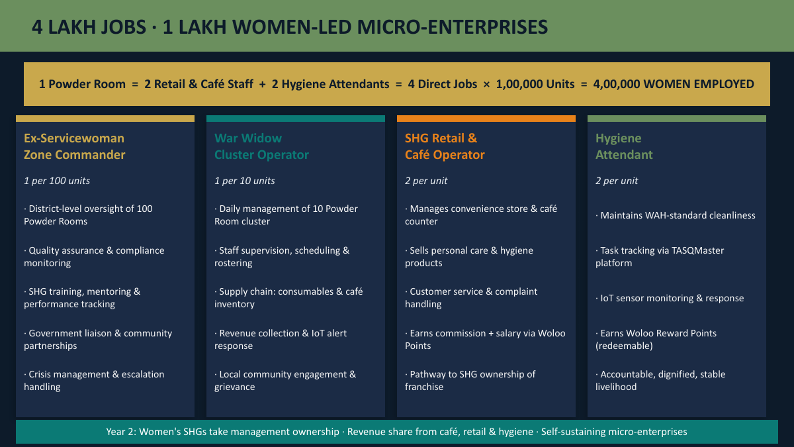
Projected employment impact at national scale — 4 lakh jobs and 1 lakh women-led micro-enterprises across the Woloo network.
Aligned With the UN Sustainable Development Goals
SDG | Focus Area
SDG 1 | No Poverty — stable incomes for women operators
SDG 3 | Good Health & Well-being — hygienic sanitation access
SDG 5 | Gender Equality — women-led infrastructure and safety
SDG 6 | Clean Water & Sanitation
SDG 8 | Decent Work & Economic Growth
SDG 11 | Sustainable Cities & Communities
SDG 12 | Responsible Consumption & Production — waste-to-resource
SDG 17 | Partnerships for the Goals

Governance, Compliance & Audit
- Registered under the Indian Trusts Act — 12AA and 80G certified
- CSR-1 registered — eligible for corporate CSR funding under the Companies Act, 2013
- Annual independent financial audit
- Field verification visits available on request for CSR partners
- BRSR-ready impact data for listed-company reporting
Downloads
- [Download] Annual Report
- [Download] 12AA / 80G / CSR-1 Certificates
- [Download] Audited Financial Statements
- [Download] Impact Report (latest quarter)

Page 5 — PARTNER WITH US
Hero
Headline:
“However You Give, It Builds Dignity.”
Sub-headline:
Whether you're a corporate CSR team, a travel platform, or an individual donor — there's a way to be part of this that fits you.
For Corporates — CSR Partnerships
Gramonnati Trust is CSR-1 registered, 12AA and 80G certified — making every contribution fully eligible under Schedule VII of the Companies Act, 2013, with 50% tax deduction under Section 80G.
Tier | Contribution | Recognition
Mission Partner | ₹25 Cr+ | National programme naming rights; flagship co-branding across the Woloo network
State Partner | ₹5-25 Cr | State/region-level naming rights; dedicated impact reporting
City/Title Partner | ₹2-5 Cr | Naming rights across a city cluster (e.g., Pondicherry's 10 units)
Zone/Unit Sponsor | ₹25L-1 Cr | Branding on specific units or zones
Community Partner | ₹50L-2 Cr | Gratitude Wall recognition + ESG report feature

For Travel & Hospitality Brands
Integrate the Clean & Divine India ₹10 Guilt-Free Travel contribution into your booking flow via our EPS API. See the
Travel Partnerships page
for details.
For Individuals — Crowdfunding & Donations
Every Woloo unit campaign runs on FuelADream, India's trusted crowdfunding platform for social causes. Your contribution — large or small — is acknowledged on our Gratitude Wall and is eligible for an 80G tax receipt.
Contribution | Recognition
₹1 Lakh+ | Listed under Community Champions
₹5 Lakh+ | Name engraved on the Gratitude Wall + digital recognition
₹40 Lakh+ (full unit) | Naming rights on a complete Woloo unit

[CTA] Donate via FuelADream | [CTA] Set Up a Recurring Gift
For Volunteers & Supporters
- Spread the word — follow and share our campaigns
- Corporate volunteering — team visits to operational Woloo units
- Skilled volunteering — design, communications, data and impact-measurement support
Tax Benefits at a Glance
- 80G — 50% deduction on donations for Indian taxpayers
- CSR-1 registered — fully eligible for corporate CSR spend
- 12AA — income-tax exempt status for the Trust

Page 6 — CONTACT US
Hero
Headline:
“Let's Build This Together.”
Sub-headline:
Whether you're exploring a CSR partnership, a crowdfunding contribution, media enquiry, or volunteering — we'd love to hear from you.
Reach Us
Channel | Details
General enquiries | info@gramonnati.org
Partnerships & CSR | ved@gramonnati.org
Phone (Mobile) | +91 80959 99776
Website | www.gramonnati.org

Visit Us
[Insert registered office address from Trust Profile]
Puducherry, India
Contact Form Fields
- Name
- Organisation (optional)
- Email
- Phone
- I'm interested in: [dropdown — CSR Partnership / Crowdfunding & Donations / Travel Partnership / Media & Press / Volunteering / Other]
- Message
Follow Us
[Social media icon row — LinkedIn, Instagram, Facebook, YouTube, X]

PART D — Making the Website World-Class
Beyond strong content, a handful of features consistently separate a good NGO website from a world-class one — especially for organisations courting CSR funders and global crowdfunding audiences. Below is a prioritised list for the development team.
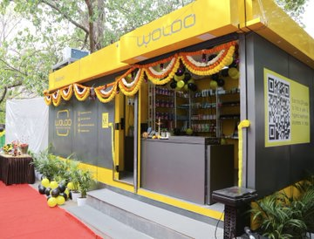
A Woloo Powder Room unit in operation — real photography like this should anchor the site's visual identity.
1. Live Impact Dashboard
A real-time (or daily-refreshed) counter showing units operational, footfalls served, women employed, and funds raised — embedded on the homepage and Impact page. This is the single highest-leverage feature for CSR credibility.
2. Interactive India Map
A clickable map showing every Woloo unit, Pellet plant, and project location — filterable by project (Pondicherry / Bengaluru / national network) and status (live / under construction / planned).
3. Video Storytelling
Short (60-90 second) videos: a day in the life of a Woloo host, a beneficiary's story, a sponsor walkthrough of a funded unit. Video converts CSR and crowdfunding visitors far better than text alone.
4. Donor & CSR Recognition Wall
A persistent, searchable digital ‘Gratitude Wall’ — every sponsor, donor and CSR partner listed with their tier, linked to the unit(s) they funded.
5. Embedded Crowdfunding Widget
Direct FuelADream campaign embeds on relevant project pages, with live progress bars — removing the friction of navigating to an external site.
6. Downloadable Transparency Pack
One-click access to 12AA/80G/CSR-1 certificates, audited financials, and the latest impact report — pre-packaged for CSR due-diligence teams.
7. Blog / News / Press Room
Regular updates on new unit launches, partner announcements, and milestones — improves SEO, keeps the site feeling alive, and gives journalists a ready resource.
8. Multilingual Support
Hindi, Tamil and regional languages (especially for Pondicherry/Tamil Nadu and Bengaluru/Karnataka audiences), alongside English — broadens reach to local communities and government stakeholders.
9. Accessibility & Performance
WCAG-compliant design (screen-reader friendly, sufficient colour contrast — especially important given the green/gold palette), fast mobile load times, and SEO-optimised metadata on every page.
10. Volunteer & Careers Portal
A simple portal for volunteer sign-ups and job openings at Woloo units — reinforcing the livelihoods narrative and building a talent pipeline.
11. Photo & Video Gallery
A growing, well-tagged gallery of units, events, and beneficiaries — organised by project and location, usable by partners for their own CSR reporting.
12. Newsletter & Email Capture
A simple sign-up for quarterly impact updates — nurtures CSR leads and crowdfunding donors over time.
13. Live Chat / Chatbot
A lightweight chatbot to answer common CSR/donor questions (tax benefits, partnership tiers, how to start) instantly, with hand-off to the team for complex enquiries.
14. Partner Logo Carousel
A rotating strip of CSR partners, sponsors and media mentions — builds instant credibility for new visitors.
15. Security & Privacy
SSL, secure donation/payment flows, and a clear privacy policy — essential for any site handling donor information and payments.

Closing Note
This blueprint is designed to be handed directly to a website development team — every page, section and call-to-action above can be mapped one-to-one to a page template, component, or content block. Tables, figures and scenario numbers marked in grey/italic should be finalised against the source documents (Pondicherry Project Note, FuelADream Deck, MakeMyTrip CSR Proposal, Guilt-Free Travel Strategy Note) before publishing.
Next steps we recommend:
- Finalise the sitemap and get sign-off from the Trust's leadership
- Commission professional photography/video at active Woloo units (Bengaluru network) for hero imagery
- Build the live impact dashboard as a shared data source feeding both the website and CSR reports
- Develop the site in phases: Home + About + Impact first (CSR-facing), then the four project pages, then Partner/Contact

